**PHP2560 Final Project**

**Air Quality Monitor**

**Group 8: Ludan Zhang, Yue Peng, Jiachen Zhang, Kun Meng**

**I. The Purpose of Our APP**

Air pollution has become a heated environmental issue all around the world. In order to deal with air pollution problems, governments all around the world have taken actions to establish monitoring stations to supervising air pollution and poisonous substance. Individuals could get information of the air pollution status at these monitoring points. However, these monitoring points are discrete. Individuals cannot know the air pollution status at other locations except for these monitoring points. Thus, we intend to create an air pollution monitor app which provide users air pollution index (API) for locations users choose and give users further pollution index trend by prediction and visualization. People can take advantage of this App to get information of the air pollution at locations they want to know and can take some moves to avoid heavy polluted areas using the advices the App gives.

**II. Intended Audience and What They Would Use It For**

The app would have significant practical value to users especially those with respiratory disease such as asthma and those more susceptible to poisonous substances such as children and elderly. The App will provide valuable air pollution prediction to those who intend to travel to other areas and want to have a preview of the air quality of their destination. In addition, our App will provide users suggestions that related to exercise based on their physical condition. Users could plan their exercise activities based on the suggestion and our air quality prediction.

**III. Changes That Were Made After the Presentation**

**a) Prediction Model**

A lot of comments asked about our prediction model and suggest to give further explanation. Thus, we added prediction model explanation in ‘Help’ page for users’ reference. The explanation is written as follows:

First of all, provide two functions which are AQI to concentration of PM2.5 and concentration of PM2.5 to AQI. Then, by using wind-bearing parameter, we firstly to calculation the azimuth between zip-code location and three closest sites.

For example, two location A (latA, longA) and B (latB, longB)

Degrees to Radians:

$$latA=\frac{latA}{180}×π$$

$$longA=\frac{longA}{180}×π$$

$$latB=\frac{latB}{180}×π$$

$$longB=\frac{longB}{180}×π$$

Projection on Cartesian Coordinate

$$\left\{\begin{aligned}X_{A}=R*\cos\left(latA\right)*cos⁡(longA) \\ Y_{A}=R*\cos\left(latA\right)*sin⁡(longA) \\ Z_{A}=R*\sin\left(latA\right)\end{aligned}\right.$$

where $R=6371.3km$ is the average radius of the earth.

Then conduct the similar calculation for B.

Central angle for each arc:

$$∠AOB=\arccos\left(\frac{X_{A}∙X_{B}+Y_{A}∙Y_{B}+X_{A}∙X_{B}}{R^{2}}\right)$$

$$∠AOC=90-latA$$

$$∠BOC=90-latB$$

$$p=\frac{∠AOB+∠AOC+∠BOC}{2}$$

According to half-angle formula:

$$∠CAB=2×arccos⁡(\sqrt{\frac{sinp∙sin⁡(p-∠BOC)}{sin⁡(∠AOC)∙sin⁡(∠AOB)}})$$

which is the B’s azimuth compared to A.

The dominant pollutant, particularly PM2.5 in haze population, is epidemiologically associated with the risk of deleterious health effects on cardiovascular and lung disease. Since SO2 and O3 have too many NA values, we mainly predict PM2.5 in the model. Instead, those two pollution use average AQI for prediction.

In this model, we select three closest monitoring sites A, B, C, to calculate the specific zip-code location. We calculate and sort distance based on latitude and longitude.

Low wind speeds over a source region allows pollutants to accumulate. High wind speeds ventilate a source region preventing local emission from accumulating. Thus, we use azimuths to determine whether the wind gives a positive or negative effect on transportation.

To calculate the PM2.5 concentration of location D

$$C_{D}=C_{A}*\left(ω_{AD}-\frac{δ∙I∙ω_{AD}}{ω_{AD}+ω_{BD}}\right)+C_{B}*\left(ω_{BD}-\frac{δ∙I∙ω_{BD}}{ω_{AD}+ω_{BD}}\right)+C_{C}*\left(ω_{CD}+δ∙I\right)$$

where $ω_{AD}+ω_{BD}+ω_{CD}=1$, $I$ denotes the wind speed.

$δ$ is a constant and it takes value of 0.03 in this model. ( $δ=0.1$ in the paper based on China’s pollution situation)

Normalized inverse distance weights (IDW) for the three closest monitoring site using simplest weighting function-inverse power.

$$w\left(d\right)=\frac{1}{d^{p}}$$

Here we use $p=2$.(The most common choice)

Assumptions:

1) Residence time refers to the time span between the PM2.5 emission and its removal from the atmosphere.

2) Residence time determines the range of impact of PM2.5.

3) PM2.5 sulfates reside 3-5 days in the atmosphere.

4) On the average, PM2.5 particles are transported 1000 or more km from the source.

5) The PM2.5 residence time increased with height.

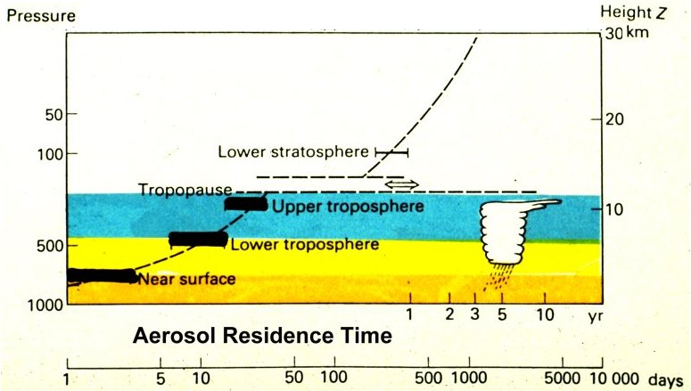

6) Within the atmospheric boundary layer (the lowest 1-2 km), the residence time is 3-5 days.

7) Assume residence time is uniformly distributed:

$$residence time\sim Unif(3, 5)$$

If lifted to 1-10 km, they are transported for weeks and many thousand miles before removal

$$residence time= \sqrt{45×elevation}$$

The residence time determines the range of transportation. And the range of transportation determines the region of influence of PM2.5. Thus, the residence time determines the number of future days in prediction model.

Reference:

Xiao Feng, Qi Li, Artificial neural networks forecasting of PM2.5 pollution using air mass trajectory based geographic model and wavelet transformation, *Atmospheric Environment*, April 2015, volume 107: 118-128

**b) Suggestion Model**

We also added explanation about how the exercises are evaluated and how we give exercise suggestion in the ‘Help’ page. The explanation is as follows:

Based on the research conducted by Giles, L.V. and Koehle titled ‘The Health Effects of Exercising in Air Pollution’, we could see that air pollution affect exercise performance and could even adverse health effect. Thus, during severe air pollution time, people should choose their exercise type and exercise place carefully.

According to Centers for Disease Control and Prevention and American College of Sports Medicine guidelines, sports that consume 3.5-7 kcal energy per minute are consider moderate activity while sports that consume more than 7 kcal energy per minute are consider vigorous activity. We categorized common type of sports which will be used in advice panel of our app. The detailed categorized result is as following:

|  |  |
| --- | --- |
| **Moderate level** | **Vigorous level** |
| Hiking | Relay race |
| Skateboarding | Taekwondo |
| Shot put | Karate |
| Boxing | Judo |
| Table tennis | Basketball |
| Swimming | Soccer |
| Diving | Handball |
| Parallel bars | Synchronized swimming |
| Trampoline | Water polo |
| Bowling | Ice hockey |
| Javelin throw | Volleyball |
| Golf | Mountain bike cycling |
| Weightlifting | Speed skating |
| Darting | Badminton |
| Motorcycling | Skiing |
| Pommel | Hockey |
| Motorboating | Hurdle racing |
| Ski jumping | Rowing |
| Equestrian events | Fencing |
| Air rifle shooting | Canoeing |
| Rifle prone | Sailing |
| Kart racing | Wrestling |

We divided air pollution risk into 5 level based on AQI. According to Nikolaos I. S., children, elderly and people with certain disease (e.g. lung cancer, asthma and Cardiovascular Disease). If user belong to one of these categories listed above, we would increase their risk level by one.

If risk level is one or two, users receive suggestion that they can do both moderate and vigorous exercise. If risk level reaches three, we give advice that users had better only do moderate exercise. If risk level is larger than three, we suggest users stay indoors and do not go out for exercise.

Reference:

[1] Yang, I. A., Fong, K. M., Zimmerman, P. V., Holgate, S. T., & Holloway, J. W. (2009). Genetic susceptibility to the respiratory effects of air pollution. *Postgraduate Medical Journal*, 85(1006), 428-436.

[2] Gilliland, F. D. (2009). Outdoor Air Pollution, Genetic Susceptibility, and Asthma Management: Opportunities for Intervention to Reduce the Burden of Asthma. *Pediatrics*, 123(Supplement).

[3] Levy, J. I., Greco, S. L., & Spengler, J. D. (2002). The Importance of Population Susceptibility for Air Pollution Risk Assessment: A Case Study of Power Plants Near Washington, DC. *Environmental Health Perspectives*, 110(12), 1253-1260.

[4] Stilianakis, N.I. (2015). Susceptibility and Vulnerability to Health Effects of Air Pollution: The Case of Nitrogen Dioxide. *Joint Research Center Technical Report,* doi:10.2788/43261.

**c) Zip code input button**

In the ‘Detail’ page, we asked users to input zip code and hit ‘GO’ button. However, users can only hit it once since we did not write code to reset the binary value of ‘GO’ button. If user input zip code multiple times, there will be an error. We have fixed this problem and now the button is well functioned. Users can input zip code multiple times and they can explore air pollution index and prediction for multiple areas.

The same thing happens in ‘Detail’ page. Previously, when users hit ‘Submit’ button in detail page, the same error may happen. We fixed this problem and now the ‘Submit’ button is will functioned.

**d) Layout improvements**

We also improved our layout in several ways to make it more users’ friendly based on the valuable suggestions we got from other groups.

First, we changed input label in advice page from gender to sex.

Second, we provided users with extra in height with unit feet and weight with unit pound.

Third, we added legend on overview map and detail map to show the scale of AQI in order to give users a better view of the magnitude of each air pollution substance.